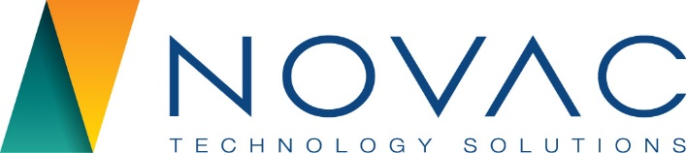

NOVAC TECHNOLOGY SOLUTIONS

User Manual

Document Version No.: 1.00

Revision History
Version No | Reason For Changes | Author | Approver
0.01 | Draft | Ravi
1.00 | Reviewed & Approved the User Manual | Ravi | NIJANTHAN PL

Table of Contents
1. Introduction 4

2. Daily Comission report 4

Introduction

The document is prepared to understand the reports generated in ZIVA application. This document is being prepared in reference to,
- Guidelines, circulars, instructions and directions released from time to time by Philippines Insurance council.

Functional Overview

System should have the provision to generate the Daily Commission report for both Motor and Non-Motor products.

Daily Commission Report

System should have the provision to generate the consolidated reports for both Motor and Non-Motor products. Required to add a one more dropdown as “All” in the Business Type input parameter field to generate the consolidated reports for both Motor and Non-Motor Products.

Search the MIS Report Screen.

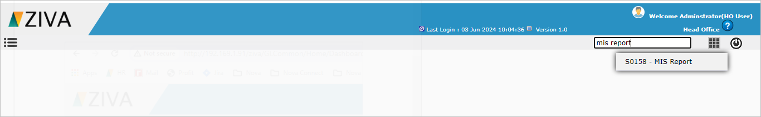

Click on the MIS Report Screen. System will display the Report details tab.

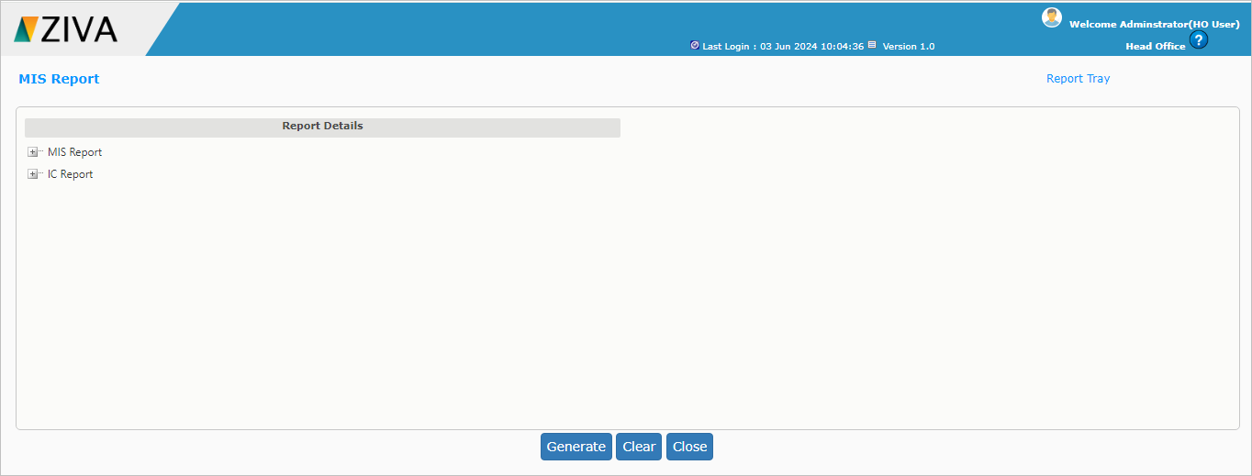

Select the COC Authentication report under the IC Report.

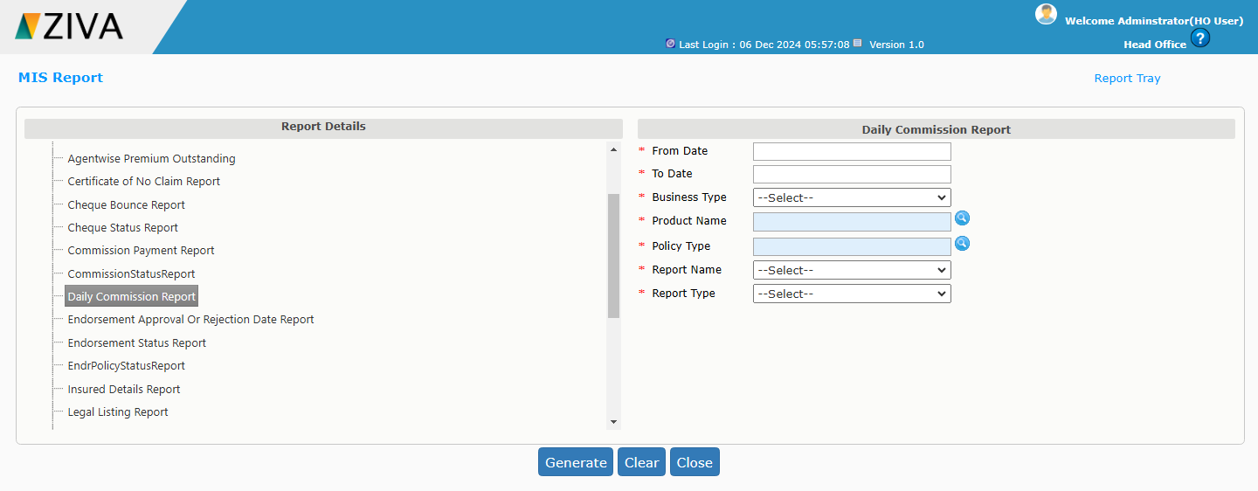

Enter all the details and click on Generate button.
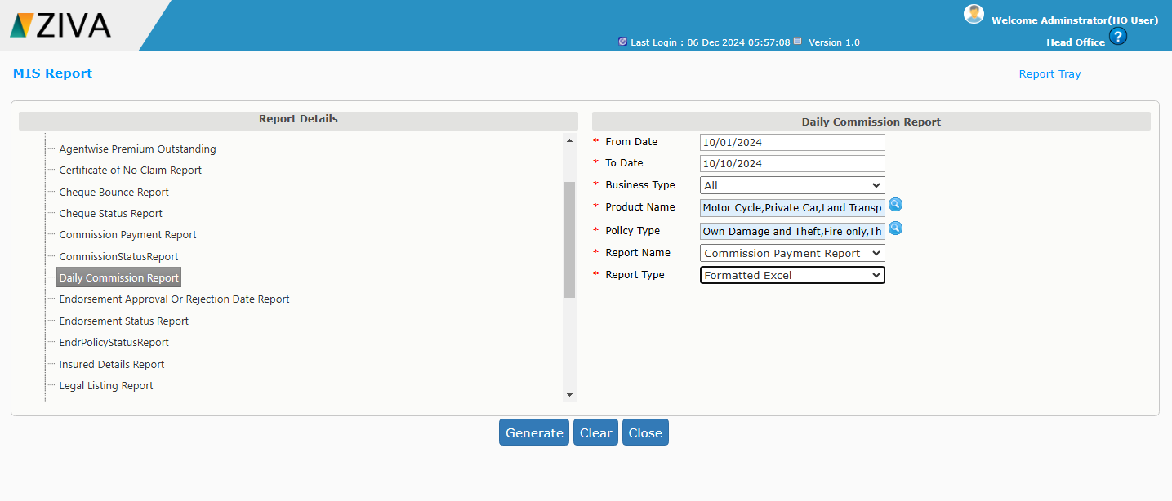

Once click on the Generate button system will display an alert message as “Report is being generated. You may now close this window. Go through Reports Tray to view the Report”.
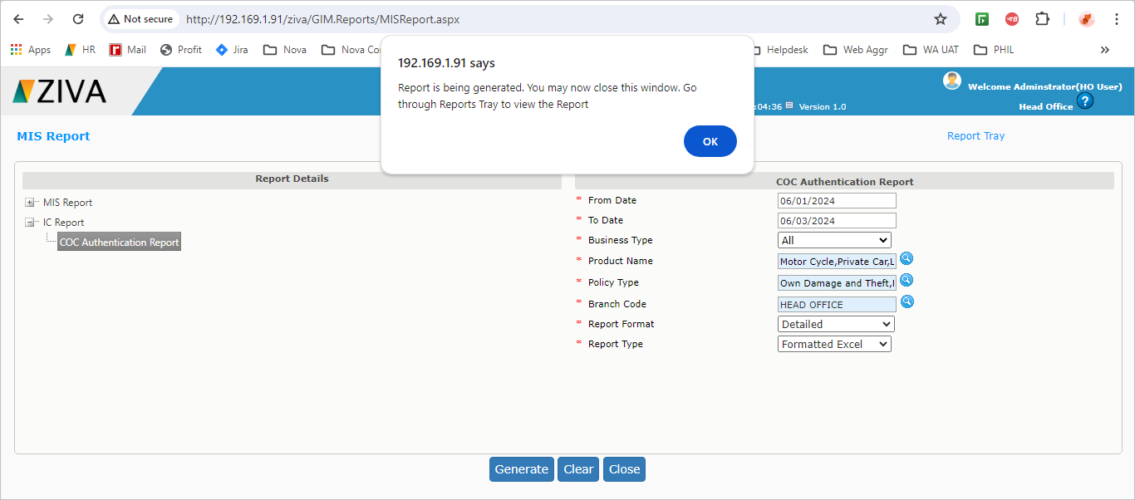

Click on the report tray link.

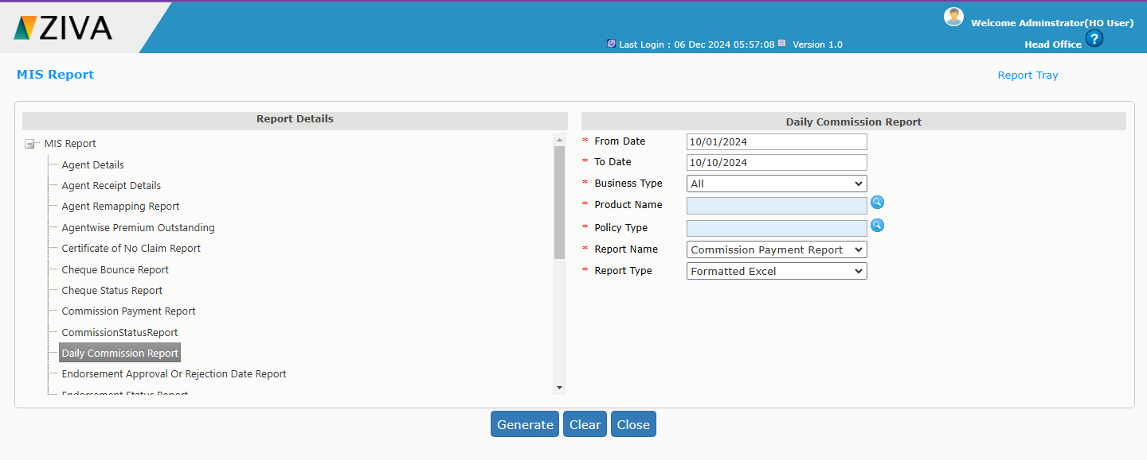

Once click on the report tray link, system will display the Daily Commission report.
Click on the view button to download the report.

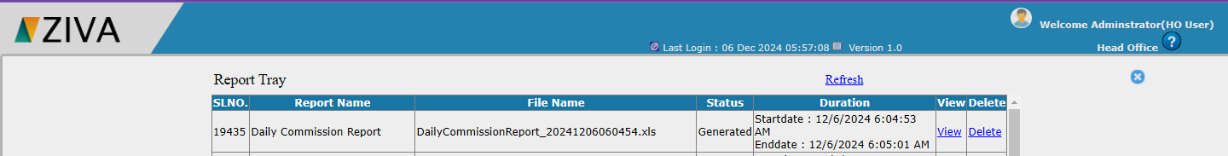

Click on X button to close the window.

